Worksheet 1.3

Student Name: Sahil Kaundal UID: 21BCS8197

Branch: CSE (Lateral Entry) Section/Group:20BCS-809_A Semester: 4th Date of Performance: 25/02/2022

Subject Name: SE Lab Subject Code: 20CSP-255

Q1.

1. Aim/Overview of the practical:

Draw a level 0 Data Flow Diagram (DFD) that fits the following system:

Students login with an email Id and password and the system provides access to the schedule for the current quarter. Students pick classes and enrol in them. Enrolments are recorded in rosters. The system formats rosters for each class and sends them to teachers. Teachers can drop students on their rosters.

The DFD should have more than one process, more than one source/sink and more than one data store. The words in bold in the above box should appear in your diagram at least once. You may have to invent some names.

1. Task to be done/ Objective:



Draw a level 0 Data Flow Diagram (DFD).

* The objective of Data Flow Diagram (DFD) is to graphically represent flow of data in an information system.
* It is capable of depicting incoming data flow, outgoing data flow and stored data.
* Training and Placement System is a software system that can store, update, and retrieve the information through Databases

1. Requirement Analysis:

Software Requirement:

* Smart Draw
* Google Chrome

Hardware Requirement:

* Computer
* Windows 10
* Power Supply

1. DATA FLOW DIAGRAM (DFD):

Data flow diagram is graphical representation of flow of data in an information system. The DFD does not mention anything about how data flows through the system. It is capable of depicting incoming data flow, outgoing data flow and stored data.

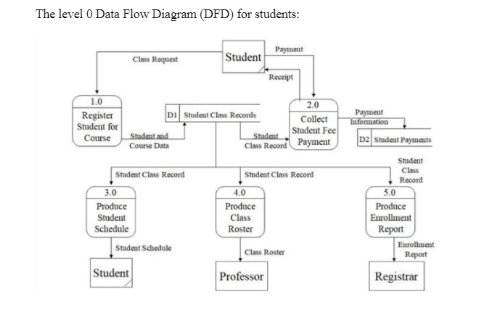

*Level 0 DFD*

The Student Enrolment System Data Flow Diagram contains five processes, four external entities and two data stores.

A student can request for a class by register for the course. The student and course will be store in the student class records. After that collect the payment and on the basis of that record produce student schedule for student, class roaster for professor and enrolment report for registrar.

Q2.

1. Aim/Overview of the practical:

Draw a level 1 DFD for the following scenario

The software proposed is Food Ordering System. It has participants who will interact with the system, called the external entities. The *Supplier*, *Kitchen*, *Manager*, and *Customer* are the entities who will interact with the system. In between the process and the external entities, there is data flow (connectors) that indicate the existence of information exchange between the entities and the system.

1. Task to be done/ Objective:



Draw a level 1 DFD.

* The objective of Data Flow Diagram (DFD) is to graphically represent flow of data in an information system.
* It is capable of depicting incoming data flow, outgoing data flow and stored data.
* Training and Placement System is a software system that can store, update, and retrieve the information through Databases.

1. Requirement Analysis:

Software Requirement:

* Smart Draw
* Google Chrome

Hardware Requirement:

* Computer
* Windows 10
* Power Supply

1. DATA FLOW DIAGRAM (DFD):

Data flow diagram is graphical representation of flow of data in an information system. The DFD does not mention anything about how data flows through the system. It is capable of depicting incoming data flow, outgoing data flow and stored data. The DFD does not mention anything about how data flows through the system.

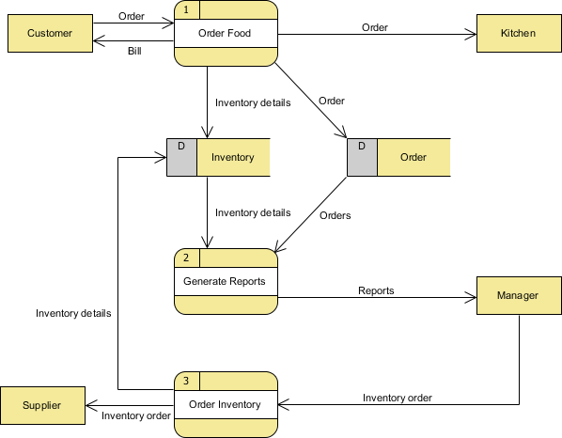

*Level 1 DFD.*

The Food Ordering System Data Flow Diagram contains three processes, four external entities and two data stores.

A Customer can place an order. The Order Food process receives the Order and forwards it to the Kitchen and store it in the Order data store and store the updated Inventory details in the Inventory data store. It also delivers a Bill to the customer.

The manager can receive reports with the help of Generate Reports process that takes Inventory details and Orders as input from the Inventory and Order data store respectively.

Manager can also initiate the Order Inventory process by providing Inventory order. The process forwards the Inventory order to the Supplier and stores the updated Inventory details in the Inventory data store.

1. Result/Output/Writing Summary:

I have successfully done this practical.

Learning outcomes (What I have learnt):

1. To learn how to draw Data Flow Diagram (DFD).
2. To Draw Different levels of Data Flow Diagram.

Evaluation Grid (To be created as per the SOP and Assessment guidelines by the faculty):



|  |  |  |  |
| --- | --- | --- | --- |
| Sr. No. | Parameters | Marks Obtained | Maximum Marks |
| 1. |  |  |  |
| 2. |  |  |  |
| 3. |  |  |  |
|  |  |  |  |